**Steps to start MemoLoom Application:**

After importing the MemoLoom project into Eclipse:

* **right-click** on the project
* navigate to **'Run'**
* select 'Run as **Java Application'.**

When the project is running, the following screen appears. Here's how to start the application:

1. **Landing Page of MemoLoom**

* This page provides an introduction to MemoLoom, explaining what MemoLoom is and why it is beneficial to use.
* It includes login and signup options for users to begin using the application.

1. **Home Page of MemoLoom**

After signing in or logging in, the user will see two panels, the left and right panels.

Let’s explore each panel:

1)Left Panel:

* **Sets:** Users can create customized sets of flashcards according to their preferences.
* **Favorites:** Users can bookmark sets they wish to review again for easy access.
* **Performance:** Users can track their progress and achievements.
* **Logout:** Users can sign out, which redirects them to the MemoLoom landing page.
* **Name:** Users can see their name in the left corner.

2) Right Panel:

* **Date:** Users can filter flashcards by date.
* **Name:** Users can sort flashcards alphabetically.
* **Search:** Users can search for specific flashcards.
* **Add Icon:** By clicking the add icon, users can either create a new flashcard or import a CSV file with their flashcards

In our project in Eclipse, we have two CSV files

* **Data.csv:** Contains a set of questions and answers.

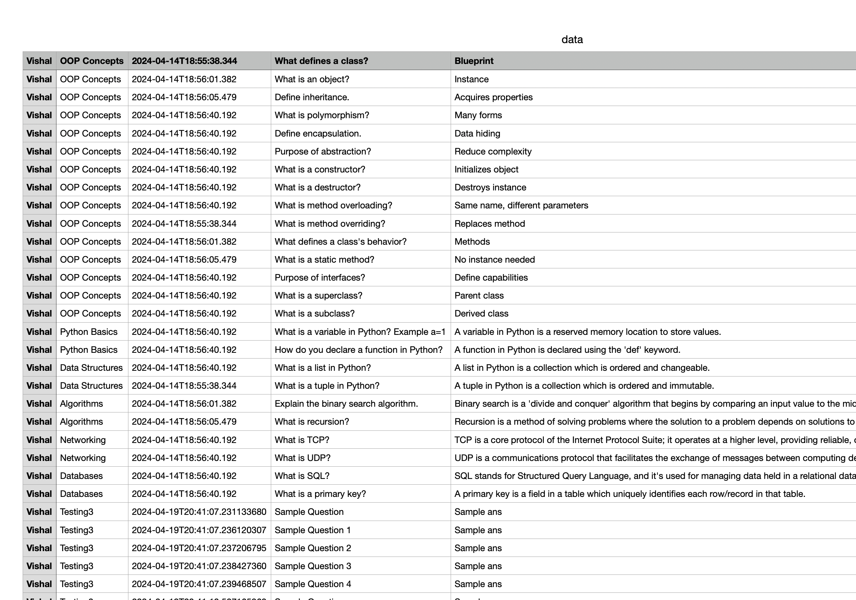

* **Data2.csv:**  This file holds sample questions and answers. Users can add customized questions and answers in the specified format without headers.

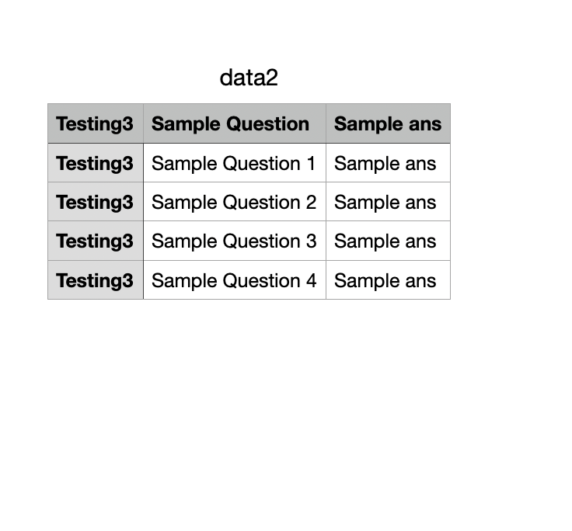

If the user imports the 'csvdata2' file, the following output will be displayed:

1. After **importing** data using either **'csvdata1'** or **'csvdata2'**

The screen will show a list of flashcards added by the user on the right panel. Users can search these flashcards by filtering by date, name, or using the search bar

1. **Users can click on any set of flashcards to view the questions within.**

They also have the option to bookmark the card (add to favorites). Navigation is possible through the arrow keys to move to the previous or next flashcard.